# Experiment No.9 Date:03/12/2021

Three Phase Systems (Star-Star/Delta) and Power Measurement

# Objectives:

1. To understand three phase balanced system star-star and star-delta
2. To measure three phase power using two wattmeter method.

**Circuit**

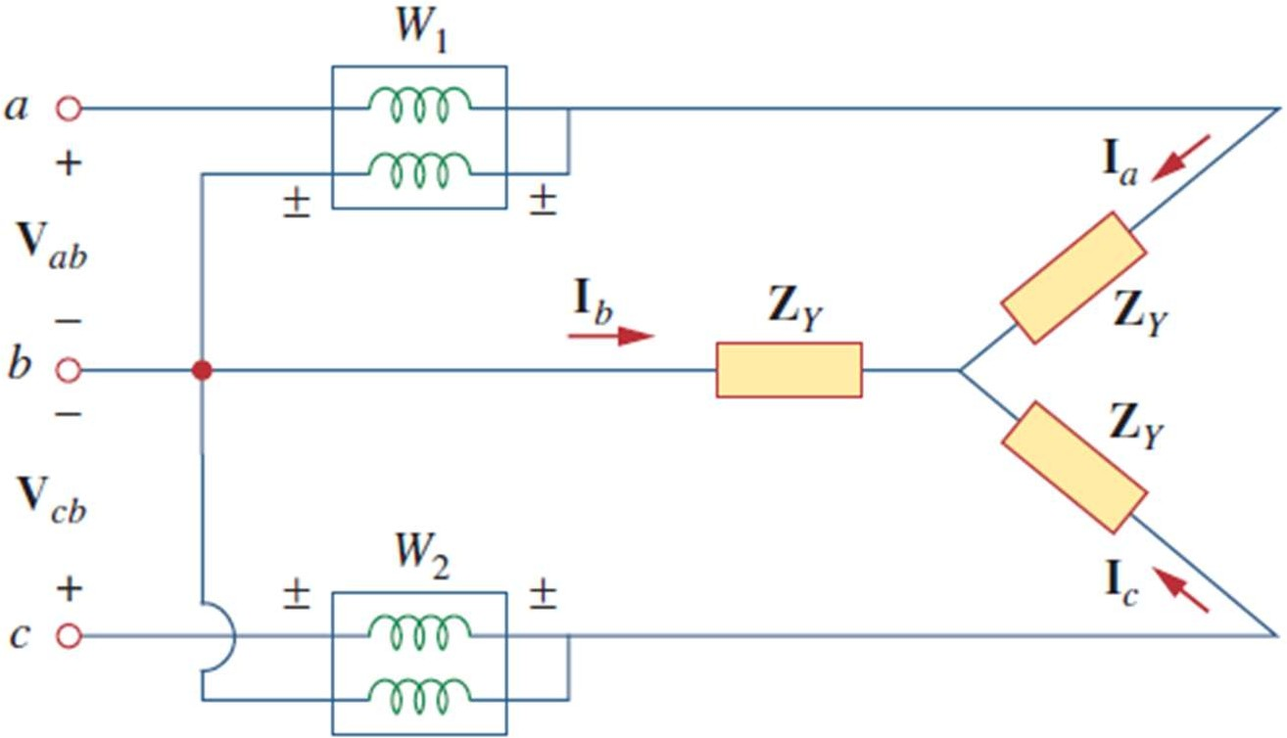

1. **R-Load:**

|  |  |  |  |  |  |  |
| --- | --- | --- | --- | --- | --- | --- |
| **S. No** | **Parameter to be measured** | **Wattmeter 1 P1= $V_{L}I_{L}\cos{φ1}$** | **Wattmeter 2 P2= $V_{L}I_{L}\cos{φ1}$** | **Real Power P=P1+P2** | **Reactive Power Q= $\sqrt{3}$ (P2-P1)** | **Power Factor cosϕ= cos(tan1(Q/P))** |
| 1 | Voltage (RMS) | 398.04 30 | 398.04 90 | 264056.862 | 0 | 1 |
| 2 | Current (RMS) | 383.01 0 | 383.01 120 |
| 3 | Phase  Angle difference | 30 | -30 |
| 4 | Power | 132028.431 | 132028.431 |
|  | $$φ1= φ+30°$$ | | $$φ2= 30°- φ$$ | |  |  |

1. **RL-Load:**

|  |  |  |  |  |  |  |
| --- | --- | --- | --- | --- | --- | --- |
| **S. No** | **Parameter to be measured** | **Wattmeter 1 P1= $V_{L}I_{L}\cos{φ1}$** | **Wattmeter 2 P2= $V_{L}I_{L}\cos{φ1}$** | **Real Power P=P1+P2** | **Reactive Power Q= $\sqrt{3}$ (P2-P1)** | **Power Factor cosϕ= cos(tan1(Q/P))** |
| 1 | Voltage (RMS) | 398.04 30 | 398.04 90 | 111801.58 | 130253.6 | 0.65(lag) |
| 2 | Current (RMS) | 249.0 -49.36 | 383.01 120 |
| 3 | Phase  Angle difference | 79.36 | -30 |
| 4 | Power | 18299.78 | 93501.8 |
|  | $$φ1= φ+30°$$ | | $$φ2= 30°- φ$$ | |  |  |

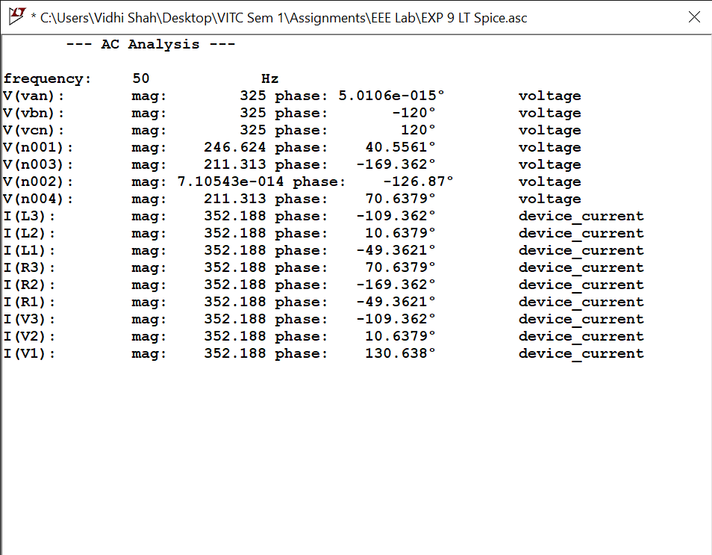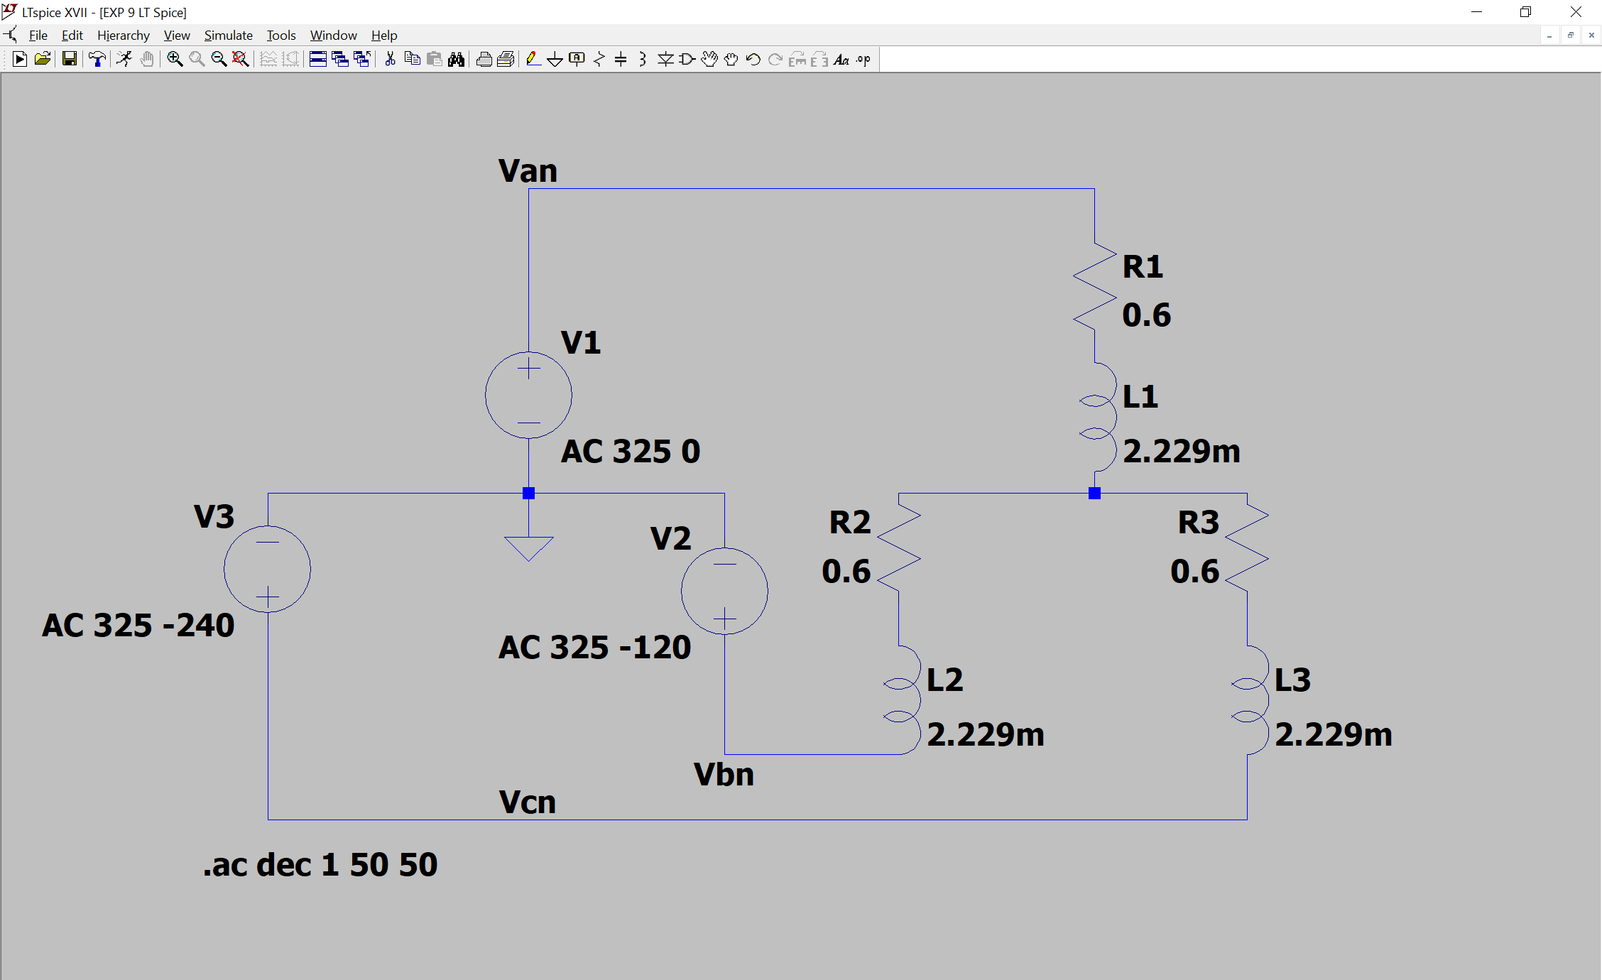

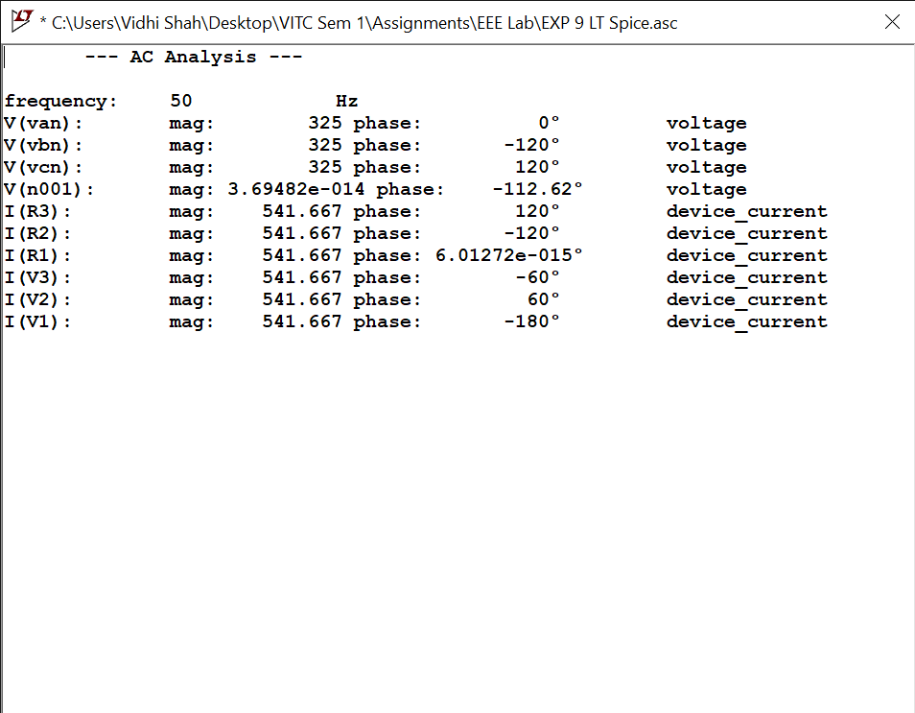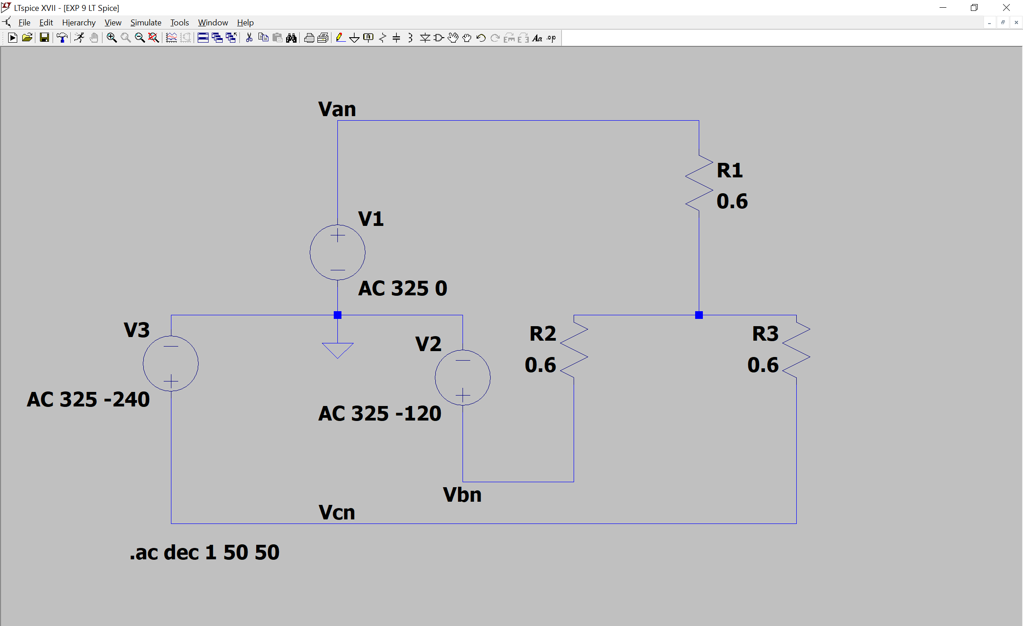

**Do it yourself for practice:**

* 1. Measure the rms values of all the above listed parameters using spice directive

.MEAS

* 1. Measure the current through neutral wire

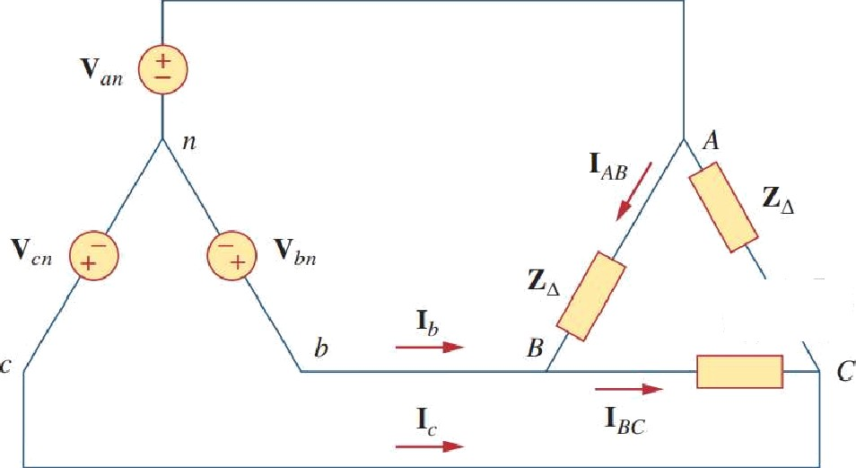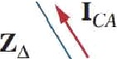

One line voltage of a balanced Y-connected source is VAB = 120 -20 V, If the source is connected to a Δ-connected load of 20 40 Ω, find the phase and line currents. Assume the abc sequence.

**Answer:** 6 -60A, 6 -180 A, 6 60 A, 10.392 -90 A, 10.392 150A, 10.392 30 A.

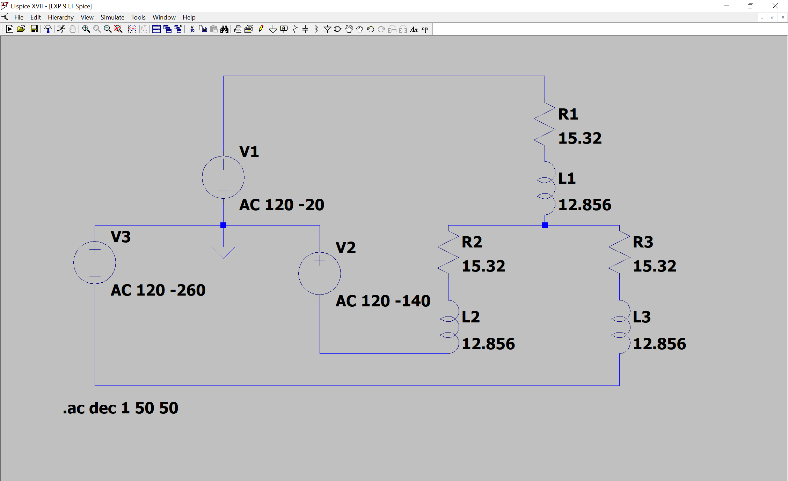

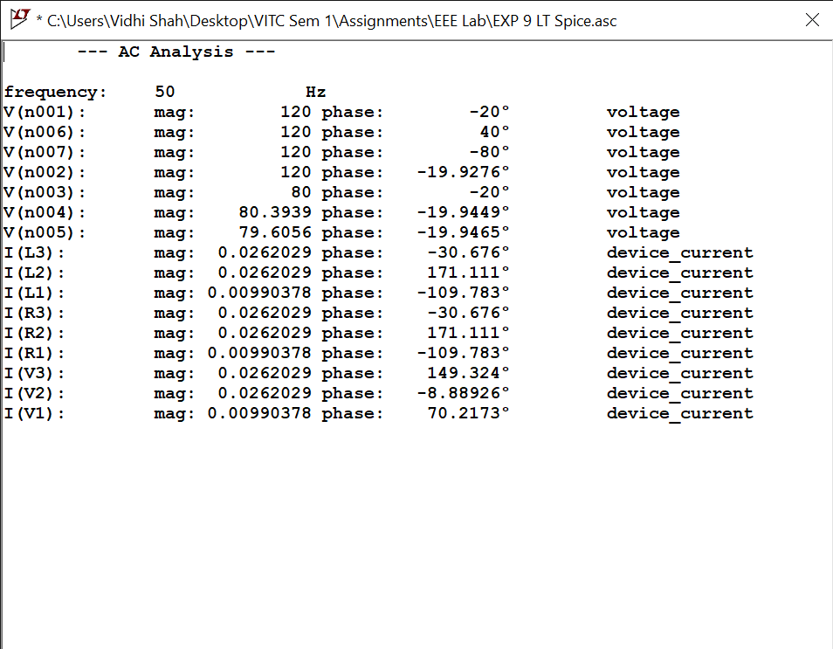

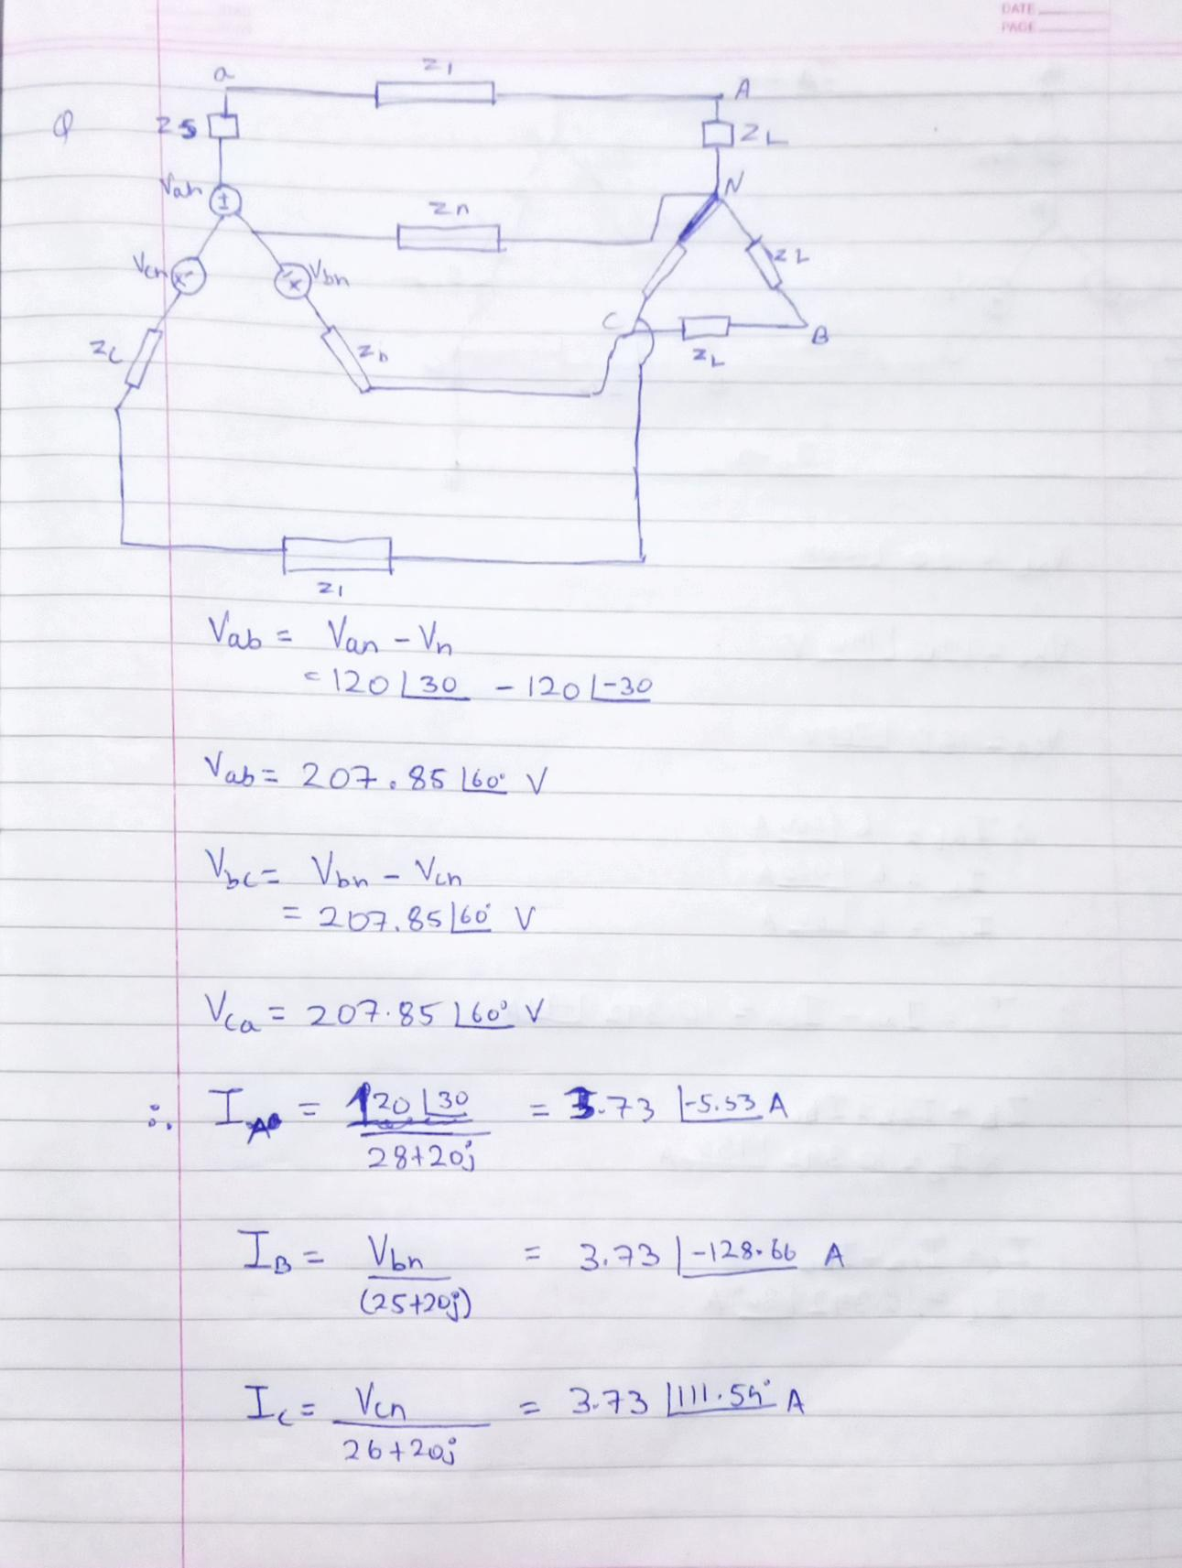**Calculations:**

